

REQUEST FOR Proposals

Home Improvement Programs

September 18, 2026

RETURN TO:
Kevin Bane
Director, Home Improvement Programs
PHDC
1234 Market Street, 17th Floor
(215) 448-3049
Kevin.Bane@phdc.phila.gov

Introduction
This Request for Proposals ("RFP") provides interested contractors with the information required to prepare and submit qualifications for consideration by the Philadelphia Housing Development Corporation ("PHDC") to satisfy the need for home rehabilitation services and accessibility modifications (""such services and modifications, an "Improvement" or the "Improvements"”) to be provided to the homes of low-income households in Philadelphia. Improvements will be paid for by grants under the following programs (collectively, "Home Improvement Programs" or "HIP"):

- Basic Systems Repair Program ("BSRP")
- Adaptive Modifications Program ("AMP")
- Targeted Housing Preservation Programs ("THPP")
- Low Income Home Energy Assistance Program ("CRISIS")
- Disaster Recovery & Resilience Program ("DRRP")

Recipients of HIP grants will be the customers of the contractors selected to participate in one or more of the Home Improvement Programs and the only remedies of all such homeowners for claims relating to any such Improvements shall exclude any claims against PHDC and instead be limited to claims against selected contractors that perform work in their homes under one or more of the Home Improvement Programs, as well as any of their subcontractors, representatives, agents, directors, officers, partners or employees.
Contracts will be offered for an initial one (1) year period with the option to extend for two (2) additional one (1) year renewal periods at PHDC’s sole discretion for a maximum total of three (3) years.
Typical Home Improvement Programs grant reimbursements for work performed by contractors range between $2,000 to $19,000 per property for all non-DRRP related projects.
PHDC will select qualified contractors to perform work under HIP in the following trades:
- Roofing
- Plumbing
- Carpentry
- Heating
- Electric
- Mechanical Equipment (wheelchair lifts, elevators, and stairway elevators)
- Railings
- Asbestos Remediation
- Door/Window Replacement
- Basement Waterproofing
- Drywall and insulation
- General Contracting (working on multiple trades list above)
The trades associated with each program are listed below:
BSRP/THPP/CRISIS
- Roofing
- Plumbing
- Carpentry
- Heating
- Electric
- Asbestos Remediation
- General Contracting (working on multiple trades list above)
AMP
- Mechanical Equipment (wheelchair lifts, elevators, and stairway elevators)
- Accessible Bathrooms/Kitchens
- Railings
DRRP
- Roofing
- Plumbing
- Carpentry
- Heating
- Electric
- Asbestos Remediation
- General Contracting (working on multiple trades list above)
- Door/Window Replacement
- Basement Waterproofing
- Drywall and insulation

Response Date
- Complete responses to this RFP ("Response(s)") must be received by 12:00PM on Friday, October 16, 2026 to be considered. Applicants may submit Responses by any of the following methods:
- https://phdcphila.org/professional-services-rfps/
- by email to Kevin.Bane@phdc.phila.gov
- by hand delivery to PHDC at 1234 Market Street, 17th Floor, Philadelphia PA 19107
- or by US Mail or another commercial courier

If submitting by website or email, please email Kevin.Bane@phdc.phila.gov to confirm receipt.

- Applicants may submit only one (1) Response to this RFP. Individuals or businesses that are legally related to each other or share an affiliation with a common entity may not submit separate responses. PHDC, in its sole discretion, retains the right to reject any Response where:
  - Applicants or principals of applicants are substantially similar or substantially similar related parties; or;
  - PHDC has determined that the applicant has violated these conditions or the spirit of these conditions.
- Responses will be disqualified if:
  - They are submitted by some means other than the format listed above; and/or
  - If the Response package is incomplete.

Questions
Contractors may submit questions regarding this RFP to Kevin.Bane@phdc.phila.gov by Wednesday, 9/30/26. The questions and answers will be posted on PHDC website where this RFP is posted (https://phdcphila.org/professional-services-rfps/) by EOD Friday, October 2, 2026.

Eligible Services
PHDC’s HIP provide grants to pay for Improvements in homes of income-eligible Philadelphia households. Requests for HIP grants come through PHDC’s HIP Hotline as well as direct referrals from community partners. PHDC staff inspects eligible properties to develop a list of repair needs and modifications which may be addressed through the Home Improvement Program(s). Work orders for eligible Improvements are sent to participating contractors to prepare estimates for approval by PHDC and proceed orders are issued to selected contractors.

The various Home Improvement Programs provide different levels of Improvements. Contractors are expected to pay close attention to the requests for estimates ordered and to contact PHDC with any questions.

All work must comply with all applicable statutes, regulations and codes. Homeowners' may seek applicable remedies against contractors that performed work at their homes, and any of their subcontractors, representatives, agents, directors, officers, partners, or employees, for any noncompliance with such statues, regulations or codes.

Lead-Based Paint
U.S. Department of Housing and Urban Development ("HUD") Title X regulations, in effect as law since September 15, 2000, as amended, have added demands to HIP and other federally funded programs with respect to lead dust control. All contractors participating in all HIP programs will be required to comply with such regulations and exercise appropriate care to contain dust, particularly wherever paint may be disturbed. Homeowners may seek applicable remedies against selected contractors that performed work in their homes, and any of their subcontractors, representatives, agents, directors, officers, partners, or employees, for any noncompliance of such regulations or failure to exercise due care.

Additionally, all contractors selected to be reimbursed under HIP grants in all Home Improvement Programs shall possess a Lead-Safe Firm certification from the Environmental Protection Agency and shall have relevant jobs overseen by a certified Lead Renovator.

Work Procedures
- PHDC determines client eligibility and what Improvements are needed at each property.

- Requests for estimates will be sent to contractors through PHDC’s Contractor Portal only. Contractors will make appointments and inspect each property for requested Improvements and enter specifications in the Contractor Portal for approval by PHDC.

- PHDC will issue proceed orders for approved estimates or will notify the contractor that an Improvement is not approved and pay the contractor a Proposal Fee for his/her time in preparing the estimate. Proceed orders will have due dates by which work must be completed.

- Contractors and their employees and subcontractors shall be respectful of residents and shall communicate in a professional manner. Under no circumstances shall a contractor or subcontractor show up at a house to work without an appointment. Careful attention shall be given to the health and safety of workers and residents. Contractors shall contain dust while working and do a careful clean-up at the end of each workday. Contractors alone shall be responsible for reporting any hazardous conditions to PHDC and residents.

- Contractors shall permit PHDC to inspect all buried piping or other covered work (roof rafters, wiring, underfloor plumbing, etc.) while repairs are in process and before piping is covered. Contractors must inform PHDC not less than one (1) day prior to covering the work to allow for the inspection to take place and shall submit photos of covered work with final documents. Contractors alone shall be responsible for any defective or incomplete repairs involving any such piping, as well as any failure to identify any hazardous conditions related to the piping.

- If based upon their expertise, contractors determine that change orders are necessary, contractors shall submit requests in accordance with the change order procedure attached as Exhibit A.

- Contractors will submit final paperwork and photos through the Contractor Portal within five business days of completing work. Upon receipt of all required paperwork, PHDC will schedule a final inspection of the work.

- Upon a successful final inspection, PHDC will create a purchase order for payment to contractor. Typical payment is made within thirty (30) days of the final inspection.

- Final documents submitted by contractors at completion of job must include:
  - Permits (plumbing, electrical, alteration, warm air, roofs (if rip off required)).
  - Roof guarantee for roofs. Equipment guarantees for house and water heaters.
  - House heater performance rating and specifications.
  - Underwriter’s certification for electrical work must be submitted within forty-five (45) days of work completion and is required prior to release of payment.

- Contractors, and any of their subcontractors, representatives, agents, directors, officers, partners, or employees, shall be solely liable to homeowners for any defective or incomplete work performed in their homes, as well as any failure to identify hazardous conditions associated with any such work. For the avoidance of doubt, PHDC shall have no liability for any such defective or incomplete work nor any failure to identify hazardous conditions associated with any such work.

Compensation

Contractors will be reimbursed by PHDC through HIP grants in accordance with the descriptions provided in the PHDC HIP Price List. Unless otherwise noted, the contractor shall invoice using the PHDC HIP Price List in effect at the time the work order is issued. PHDC reserves the right to change or adjust the price list throughout the term of the contract as it deems necessary. All price changes will be clearly communicated to all contractors in writing as they occur. Electronic copies of the current price list are available upon request.

Warranty
Contractors will warrant that all work, services, and products, including, but not limited to, labor and installation, shall be free from defects in material and workmanship for a period of at least one (1) year from the date of completion as noted in the Contractor Portal. Roof replacements shall be warranted five (5) years from the date of completion and mechanical equipment shall be warranted for three (3) years from the date of completion.

Defective materials and workmanship claimed during the warranty period must be repaired or replaced if not reasonably repairable, at no cost to PHDC or the grant recipient. The repair or replacement of defects must be covered by contractor if notice is given within the warranty period.

Non-Discrimination

ECONOMIC OPPORTUNITY REQUIREMENTS

PHDC works to ensure that all businesses desiring to do business with PHDC have an equal opportunity to compete, free from unlawful discrimination. In furtherance of this goal, PHDC reserves the right to track the participation of businesses, and to collect other contracting data, at all tiers of contracting. Applicants must agree to comply with requests for the collection, retention, and reporting of data relating to contracting at any tier, including subcontracts, and must agree that PHDC may conduct periodic reviews to monitor compliance with the collection of data relating to contracting at any tier, including subcontracts. While PHDC retains the right to request data regarding the participation of businesses, all vendors are encouraged to apply regardless of the composition of their ownership and/or workforce, and no selected vendor shall be penalized due to the composition of their ownership and/or workforce as reported in response to a request for data.

- NEIGHBORHOOD BENEFIT STRATEGY
In accordance with Executive Order 2-95, the City has established a neighborhood benefit policy relating to opportunities for training, employment and contracts for work arising in connection with the planning, construction, rehabilitation, and operation of housing assisted by DHCD and OEO.
Each contractor shall be encouraged to (1) establish a goal of employing low and very low-income neighborhood and area residents at fifty percent (50%) or more of the aggregate number of new hires on the contract and (2) establish a goal of awarding fifty percent (50%) or more of the aggregate value of all construction contracts and service contracts associated with this contract to neighborhood and area businesses.
Contractors will be required to submit as part of their Economic Opportunity Plans, a "Neighborhood Benefit Strategy" which shall describe contractor’s proposed efforts to comply with the above goals. The Neighborhood Benefit Strategy will be reviewed for compliance with DHCD staff.

- SECTION 3 TRAINING AND EMPLOYMENT (BSRP only)

Under Title I of the Housing and Community Development Act of 1974 as amended, and Section 3 of the Housing and Urban Development Act of 1968, when applicable, requires that wherever possible, opportunities for training and employment be given to lower income persons residing in the project area. Contracts for work in connection with the project must be awarded, whenever possible, to eligible businesses located in or owned in substantial part by residents of the same Section 3 area as the project. The contractor shall be subject to the requirements set forth in the Economic Opportunity and Affirmative Action Requirements.

Copies of the Economic Opportunity and Affirmative Action Requirements are available from the DHCD Compliance Unit.

Subcontracting
General contractors may subcontract the performance but not the administration of assigned work. All contractors must be active participants in the work assigned to them. Contractors who are assigned work shall be responsible for quality control and for the rapid response to all field questions and problems. Subcontractors shall not be relied on for this purpose. Failure to comply will result in termination of the contract.

Specific trade contractors may not subcontract assigned work in their specialty without written approval from PHDC.

Contractors who need to subcontract work must indicate all intended subcontractors in their RFP response. Contractors are free to change or add subcontractors during the period of the contract, however, these changes must be documented with and approved in writing by PHDC along with submission of the new subcontractor qualifications, licenses, contracts, and insurance documents for approval.

Any work performed for the contractor by a subcontractor shall be pursuant to a written contract between the contractor and the subcontractor that requires the subcontractor to (i) comply with all terms and conditions in the contract between PHDC and the contractor, (ii) perform all work in accordance with the requirements of the contract between PHDC and the contractor and (iii) be paid by the contractor no later than thirty (30) days after receiving payment from PHDC for any work performed. The contractor shall promptly report all payment disputes with the subcontractor to PHDC.

All written contracts that a contractor enters with subcontractors must identify the contractor and each subcontractor as "Contractor" and "Subcontractor" and contain the following language:

"Subcontractor acknowledges and agrees to assume, faithfully perform and comply with all requirements and obligations of Contractor under the terms and conditions of the contract between the Philadelphia Housing Development Corporation ("PHDC") and Contractor, with said contract sections being incorporated and adopted herein by reference as though fully set forth herein, to the same extent required and as if Subcontractor, and not Contractor, was required to comply with said requirements and obligations under the contract between PHDC and Contractor."

Failure to comply with all foregoing subcontractor requirements may result in the imposition of immediate sanctions, which include without limitation suspension or termination.

Selection of Contractors
The RFP Review Committee will review all Responses received. Responses will be reviewed and rated independently by two (2) or more committee members. The Committee as a whole will make final contractor and contract size recommendations. The PHDC Contract Review Committee will review all recommendations made by the RFP Review Committee before submitting recommendations to PHDC’s Board of Directors for approval.

- THRESHOLD CRITERIA
PHDC has established certain threshold criteria that must be met by all Applicants:

  - The Applicant must have a minimum of three (3) years of experience with the trade for which he/she/it is applying to and been in business as the same legal entity a minimum of one (1) year.

  - The Applicant must have a verifiable track record of responsiveness and quality work either with PHDC or with confirmed references. (An Applicant who has previously performed unsatisfactory work on behalf of PHDC, as determined by PHDC in its sole discretion, may be eliminated from further consideration.)

  - The Applicant must make a good faith effort to comply with the Neighborhood Benefit Strategy goals.

  - The Applicant must have the appropriate trade license(s). Plumbers and electricians must be licensed in their trade. All other Applicant must have a City Contractor License.

  - The Applicant must be registered with the Pennsylvania Attorney General’s Office as a Home Improvement Contractor.

  - The Applicant must demonstrate financial, legal and technological resources sufficient to perform work in a timely manner.

Applicants who do not meet the above threshold criteria will be eliminated from further consideration.

- EVALUATION CRITERIA

Once it is established that a contractor has met all threshold criteria, the Applicant will be evaluated for contract award size. Evaluation will include:

- The Applicant's demonstrated financial capacity to manage work with at least sixty (60) days of cash flow, corresponding to the peak portion of the proposed production schedule.

- The Applicant's demonstrated production capacity (i.e., crew size, equipment, subcontractor performance and ability to perform the work proposed in conjunction with other expected business). Both the contractor’s Response and their past performance with HIP will be reviewed to help determine capacity questions.

- The Applicant's experience performing similar work required by HIP with external clients (if new contractor) or with PHDC (if existing contractor in HIP)

- The Applicant’s work quality, as solely judged by PHDC.

- The number of other Applicants applying, or that previously applied, for contracts in the same trades who have been approved to provide services subject to reimbursement under program grants.

- Funding for the various HIP grants made available to PHDC.

- Client demand for various trades.

Contract Award
PHDC intends to enter into contracts for HIP grant reimbursement with the contractor(s) recommended by the committees and approved by the Board of Directors.

The contract(s) resulting from this RFP will be awarded to the qualified Applicant(s) whose qualifications will be the most advantageous to PHDC and HIP grant recipients.

The selected Applicant(s) will be required to execute a contract prepared by PHDC. The General Terms and Conditions which will be a part of that document will include, but not be limited to:

- Administrative requirements
- Conflicts of interest
- Environmental requirements
- Liability indemnification in the event of claims

A copy of the General Terms and Conditions is available upon request.

Insurance Requirements
Minimum insurance requirements for the selected contractor(s) are shown on the sample insurance certificate attached hereto as Exhibit B. Before submitting a response to this RFP, contractors should verify through their insurance carriers that they will be able to obtain the necessary insurance coverage, including, but not limited to, required completed operations, additional insured and primary and noncontributory endorsements, if selected. Contractors should not make changes to coverage to comply with PHDC requirements until notified of selection by PHDC.
Only sole proprietors and LLCs without employees, who are not required to purchase worker’s compensation insurance under Pennsylvania law, are excluded from carrying worker’s compensation coverage and must complete and submit any and all supporting documentation as requested. All other contractors will be required to carry worker’s compensation insurance. Contractors may not use subcontractors who do not carry all required insurance at the levels specified herein and name PHDC and the City as additional insureds on all liability insurance policies except workers’ compensation and professional liability insurance.

PHDC and the City of Philadelphia must be named as additional insureds on all required liability insurance policies except workers’ compensation and professional liability insurance before contracts can be finalized. All policies will include contractual liability insurance as applicable to the contractor’s obligations hereunder. All general liability insurance must include coverage for completed operations. Certificates of Insurance showing the required coverages and naming PHDC and the City as the certificate holders must be submitted along with endorsements stating that the coverage afforded PHDC and the City is "primary and noncontributory" to any other coverage available before contracts can be executed.

Qualifications Format (How to Apply)
Responses must be delivered as a complete package using the Qualifications Form. Be sure to answer all questions thoroughly and thoughtfully. Lengthy answers are not necessary or advisable. Qualifications must be typed or clearly printed. Be sure to complete the required forms provided and to supply all other items, as applicable.

For reference and convenience, pages to be returned are numbered 14 through 49 (inclusive) plus additional supporting documentation listed in the checklist (pages 12-13) is attached.

Responses with missing pages will be rejected as incomplete. Please do not velum or spiral bind qualifications. The qualifications submitted become the sole property of PHDC.

Any Applicant who willingly and knowingly provides materially false information, as verified by PHDC, will be immediately disqualified from consideration and may be referred to the appropriate authority for criminal prosecution.

An official authorized to bind the contractor to its provisions must sign the qualifications.

Reservation of Rights by PHDC
By submitting a Response in response to this RFP, an applicant affirmatively acknowledges: (i) its acceptance of the terms and conditions of this RFP; (ii) PHDC may exercise in its sole discretion the following rights; and (iii) PHDC may exercise the following rights at any time and without notice to any applicant:

- to reject any and all Responses;
- to supplement, amend, substitute, modify or re-issue the RFP with terms and conditions materially different from those set forth here;
- to cancel this RFP with or without issuing another RFP;
- to extend the time period for responding to this RFP;
- to solicit new Responses;
- to conduct personal interviews with any applicant to assess compliance with the selection criteria;
- to request additional material, clarification, confirmation or modification of any information in any and all Responses;
- to negotiate any aspect of a Response, including price;
- to terminate negotiations regarding any and all Responses at any time;
- to expressly waive any defect or technicality in any Responses;
- to rescind a selection prior to contract execution if the PHDC determines that the Response does not conform to the specifications of this RFP;
- to rescind a selection prior to contract execution if the PHDC determines that the specifications contained in this RFP are not in conformity with law or that the process in selection of an applicant or Response was not in conformity with law or with the legal obligations of PHDC;
- in the event a contract is awarded, the successful applicant or applicants shall procure and maintain during the life of the contract all required insurance coverages in the amounts to be determined prior to the award of any contract;
- in the event a contract is awarded, all applicants agree to perform their services as an independent contractor and not as an employee or agent of the PHDC;
- in the event a contract is awarded with PHDC, all applicants agree that no portion of performance of the contract shall be subcontracted without the prior written approval of PHDC; and
- each Applicant agrees to indemnify, protect and hold harmless PHDC from any and all losses, injuries, expenses, demands and claims against PHDC or the City sustained or alleged to have been sustained in connection with or resulting from (i) the submission of the Applicant's Response; (ii) the delivery by the applicant to the PHDC of any other documents or information; and (iii) any other conduct undertaken by the applicant in furtherance of or in relation to the applicant's Response. Each Applicant agrees that its duty to indemnify and hold harmless shall not be limited to the terms of any liability insurance, if any, required under this RFP or subsequent contract.
PHDC is under no obligation whatsoever to any Applicant as a result of this RFP. The RFP does not represent any commitment on the part of the PHDC to applicant. In no event shall PHDC be responsible for any cost, expense or fee incurred by or on behalf of applicant in connection with the RFP. Applicants shall be solely responsible for all such costs, expenses and fees.

PHDC HOME IMPROVEMENT PROGRAMS
REQUEST FOR PROPOSALS
CHECK LIST

The following attachments must be included as part of your qualifications. Responses with missing documents will be rejected. Use this form as a checklist to aid in the assembly of your qualifications. This form does not need to be returned.

FORMS SUPPLIED BY PHDC: The following documents must be completed by all contractors:

- Cover Sheet ( )
- Subcontractor Information ( )
- References ( )
- Production Plan & Financial Demonstration (2 pgs.) ( )
- Solicitation & Commitment Form ( )
- Executive Order 2-95 Certification ( )
- Section 3 Forms (not required for mechanical equipment providers)
  - Form A ( )
  - Form B ( )
  - Form C ( )
  - Form D ( )
- Tax Status Certification Request ( )
- Conflict of Interest Statement ( )
- Statement of No Pending or Threatened Litigation ( )
- Anti-Lobbying Certification ( )
- Minimum Wage/Benefit Certification ( )
- W-9 ( )
- Campaign Disclosure Forms (18 pgs) ( )
- Certification Form ( )

SUPPORTING DOCUMENTS – ALL CONTRACTORS: The following documents must be submitted by all contractors.

- Copy of Current Trade License or Contractor License ( )
- Copy of Current Commercial Activity License ( )
- Copies of Letters of Credit or bank statement showing cash on hand ( )
- Copy of most recent Federal Tax Return
(signed or with electronic postmark) ( )
- Copy of EPA Renovator Certification ( )
- Copy of EPA Firm Certification ( )
- Copy of PA Home Improvement Contractor Registration ( )
- Subcontractor Qualifications (insurance certificate, trade license, tax status ( )
certification and references for each subcontractor)

SUPPORTING DOCUMENTS – NON-CURRENT CONTRACTORS: The following documents must be submitted by contractors who have not contracted with PHDC in the last two (2) fiscal years:
- Articles of Incorporation and Bylaws; Certificate of Organization and ( )
Operating Agreement; Partnership Agreement; or Fictitious Name Registration
- Resumes of owners and key staff ( )

PHDC HOME IMPROVEMENT PROGRAMS –
REQUEST FOR QUALIFICATIONS
COVER SHEET

**For the Program/Trade section below, please mark off what Program you are applying for and the trades you are able to complete**

Program (Check): BSRP/THPP ___ AMP___ DRRP ___ CRISIS ___

Trade (check): Roofing ___
Plumbing ___
Electric ___
Carpentry/Masonry ___
Heating ___
General Contractor* ___
Asbestos ___
AMP - Mechanical Equip (Stair-glides/Wheelchair Lifts) ___
AMP - Accessible Modifications (Bathroom/Kitchen) ___
AMP – Railings ___
(* General contractors must provide electric, heating, plumbing, carpentry & masonry services. None of the other trades should be marked off and ONLY General Contractor should be selected if you can perform all the trades listed previously. If you are applying for DRRP, you must be a General Contractor)

FIRM NAME: ________________________________________________________________

ADDRESS: ______________________________________________________

TELEPHONE: __________________________ FAX: ______________________

CONTACT PERSON: ____________________________________________________

EMAIL (required): __________________________ CELL PHONE: _____________

TYPE OF BUSINESS: Sole Proprietorship ____ Partnership ____ Corporation ___ LLC ____

FEDERAL EIN / TAX IDENTIFICATION NUMBER: ____________________________

DATE OF INCORPORATION / ORGANIZATION / INITIATION: ________________________________

COMMERCIAL ACTIVITY LICENSE # ______________________________ (attach copy)

PHILA CONTRACTOR OR SPECIALTY LICENSE #____________________ (attach copy)

PA HOME IMPROVEMENT CONTRACTOR #_________________________ (attach copy)

TOTAL STAFF: Administrative/Supervisory: ____ Construction: ______ Clerical: _______

TOTAL GROSS SALES FOR LAST COMPLETED FY (from IRS documents): $________

MBE/WBE/DBE Certified? No _____ Yes _____ (attach certification)

MINORITY or FEMALE OWNED? Minority _____ Female _____ Both _____ Neither _____

Have any of the company’s principal officers, partners, members or owners been indicted or convicted of a felony? No_____ Yes_____ (please explain circumstances and final disposition on a separate sheet)

SIGNED: _______________________________________ DATE: ________________

PRINTED NAME & TITLE:

HOME IMPROVEMENT PROGRAMS RFP Contractor: ________________________

SUBCONTRACTOR INFORMATION

Provide information for all proposed subcontractors to be used. Please include insurance certificate and trade license for each subcontractor listed below. Please duplicate this page if more subcontractors need to be listed.

Subcontractor Business Name: _____________________________________ Trade: _______________________

Describe intended use of the subcontractor (trade, percentage of your contract)

List of two largest customers from 2025/2026, other than PHDC (phone # must be included):

Customer 1: ____________________________________
Point of Contact: ________________________________
Phone: _________________________________________

Customer 2: ____________________________________
Point of Contact: ________________________________
Phone: _________________________________________

Subcontractor Business Name: _____________________________________ Trade: _______________________

Describe intended use of the subcontractor (trade, percentage of your contract)

List of two largest customers from 2025/2026, other than PHDC (phone # must be included):

Customer 1: ____________________________________
Point of Contact: ________________________________
Phone: _________________________________________

Customer 2: ____________________________________
Point of Contact: ________________________________
Phone: _________________________________________

HOME IMPROVEMENT PROGRAMS RFP Contractor: ________________________

REFERENCES

Please list five references for residential work completed within the last year in the City of Philadelphia, indicating property address, description of work, monetary value of work, contact person and telephone number for each job. PHDC will contact three by telephone. Please notify each reference of the possibility of PHDC calling. Points will be deducted if reference is not notified of use as a reference. Individual properties must be listed, do not list a property more than once.

1. Name: ______________________________________________________________
Address & Phone: ________________________________________________________
Type of Work: ___________________________________________________________
Date Completed: ________________________________ Dollar Amount: $__________

2. Name: ______________________________________________________________
Address & Phone: ________________________________________________________
Type of Work: ___________________________________________________________
Date Completed: ________________________________ Dollar Amount: $__________

3. Name: ______________________________________________________________
Address & Phone: ________________________________________________________
Type of Work: ___________________________________________________________
Date Completed: ________________________________ Dollar Amount: $__________

4. Name: ______________________________________________________________
Address & Phone: ________________________________________________________
Type of Work: ___________________________________________________________
Date Completed: ________________________________ Dollar Amount: $__________

5. Name: ______________________________________________________________
Address & Phone: ________________________________________________________
Type of Work: ___________________________________________________________
Date Completed: ________________________________ Dollar Amount: $__________

HOME IMPROVEMENT PROGRAMS RFP Contractor: ________________________

PRODUCTION PLAN
(enter number of projected completions for each month)

Your projections should be based on how many repairs in each trade applied for which you can reasonably accomplish each month given other commitments. PHDC will use your input to help decide contract sizes.

Trade | Average Cost | # of Jobs Per Month | $ Per Month
Asbestos Remediation | $4,800
Carpentry/Masonry | $7,500
Electric | $6,000
Heating | $5,000
Plumbing | $8,500
Roofing | $14,000
Accessible Bath/Half Bath | $17,500
Stairway Elevator | $6,000
Wheelchair Lifts | $18,500
Wrought Iron Railings | $2,000
Basement Waterproofing | $20,000

Estimate the percentage of your work that will be for this contract for the above months: _________

How many field crews will you use for this contract? _______

Estimate average days between job assignment from PHDC and proceeding with work: _______

Estimate average days between starting job and job completion: _______

HOME IMPROVEMENT PROGRAMS RFP Contractor: ________________________

FINANCIAL DEMONSTRATION

NOTE: Resources described on this page must be substantiated with documentation submitted to PHDC. Acceptable documentation includes recent bank statements or lines of credit showing company name, date and available cash/credit. Only show available amounts, not total credit lines.

Source | Funds Available
Cash (bank accounts)
Credit (bank, lending institutions)
Credit (suppliers)
Total

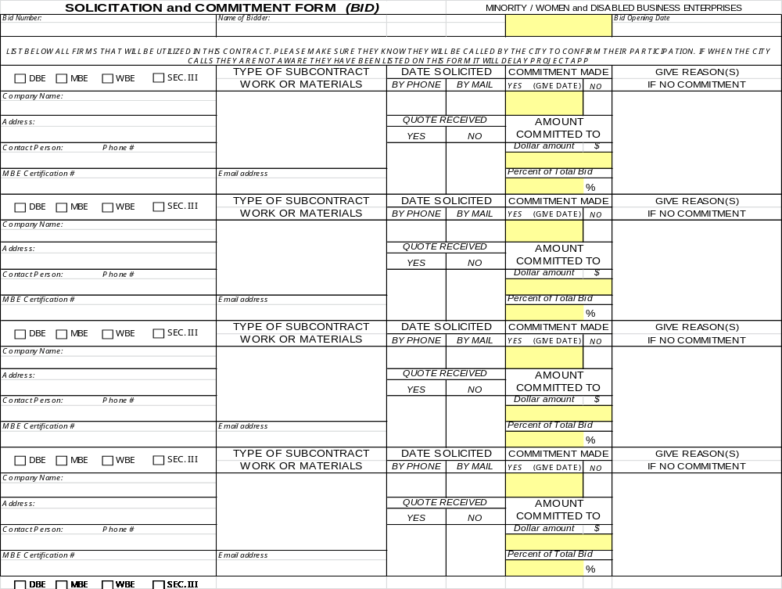
EXECUTIVE ORDER 2-95 CERTIFICATION
NEIGHBORHOOD BENEFIT STRATEGY

Pursuant to Executive Order 2-95 issued by the Mayor of the City on January 31, 1995, each project sponsor, developer, or builder working on a housing or community development project that is funded by PHDC, DHCD or the Department of Commerce or their designees, whether such project is financed in part by HUD funds, certifies and covenants

- That to the greatest extent feasible, opportunities for training and employment arising in connection with the planning, construction, rehabilitation and operation of housing assisted under such projects shall be given to people of low and very low income residing in the areas of such projects; and

- That to the greatest extent feasible, contracts for work to be performed pursuant to such projects shall be awarded to business concerns including individuals or firms doing business in the field of design, architecture, including building construction, rehabilitation, maintenance, or repair, that are owned by, employ or otherwise provide economic opportunities to low or very low-income persons residing in the areas of such projects.

Furthermore:

- Project sponsors, developers or builders receiving PHDC, DHCD or Department of Commerce funds for housing and community development projects are encouraged to establish a goal of employing low and very low-income neighborhood area residents at fifty percent (50%) or more of the aggregate number of new hires associated with these projects.

- Project sponsors, developers or builders are encouraged to establish a goal of awarding fifty percent (50%) or more of the aggregate value of all construction contracts and service contracts associated with these projects to neighborhood area businesses.

These goals should not be construed as requirements, quotas, set asides, or a cap on hiring or contracting with low and very low-income individuals and businesses. However, the goals, if met, constitute a safe harbor for project sponsors, developers, and builders on the issue of compliance with this order.

Neighborhood Benefit Strategy certification is required by all project sponsors, developers or builders submitting qualifications in response to this Request. The respondent certifies and agrees that it is under no contractual obligation or other disability which would prevent it from complying with these requirements.

______________________________________________________________________
Date Signature

______________________________________________________________________
Title Name (type or print)

Section 3 – Form A

CITY OF PHILADELPHIA
DIVISION OF HOUSING AND COMMUNITY DEVELOPMENT

SECTION 3 CERTIFICATION

(THIS FORM SHOULD BE SUBMITTED WITH PRE-CONTRACT DOCUMENTS SUCH AS A BID, RFP, RFP OR EEO/AA PLAN)

Name of Company: _______________________________________________________

Address: ________________________________________________________________

Project Title: PHDC HIP

This is to certify that I have read and understand the Section 3 resident employment and Section 3 resident business utilization requirements that apply to the above cited project, said requirements being known as the Section 3 Clause found in 24 CFR 135, and that neither the project nor the company are under any contractual restrictions or other impediment that would prevent the company from complying with said requirements.

Indicate the efforts that you will make, to the greatest extent feasible, to either train, employ or provide economic opportunities for low- and very low-income persons and toward Section 3 businesses. (Check all that apply.)

I will demonstrate compliance with the requirements of Section 3 by committing:

_____ 30% of the aggregate number of new hires each year over the duration of this project to Section 3 residents

_____ at least 10% of the total amount of all construction, rehabilitation or lead abatement subcontracts to businesses that meet the definition of Section 3 business concerns.

_____ at least 3% of the total amount of all other Section 3 covered contracts.

(Please note that, to the extent feasible, the City of Philadelphia’s Executive Order 2-95, The Neighborhood Benefit Strategy, encourages contractors to establish a goal of employing low- and very low-income neighborhood and area residents as 50 percent of new hires associated with the project and awarding 50 percent of all construction and service contracts to neighborhood and area businesses.)

Signature of Company Officer: _________________________________________________

Title of Officer: _____________________________________________________________

Date: _____________________________________________________________________

Section 3 – Form B
CITY OF PHILADELPHIA
DIVISION OF HOUSING AND COMMUNITY DEVELOPMENT

SECTION 3: ESTIMATED WORK FORCE BREAKDOWN

To be completed by contractors with pre-contract documents such as a Bid, RFP, RFP or EEO/AA Plan.

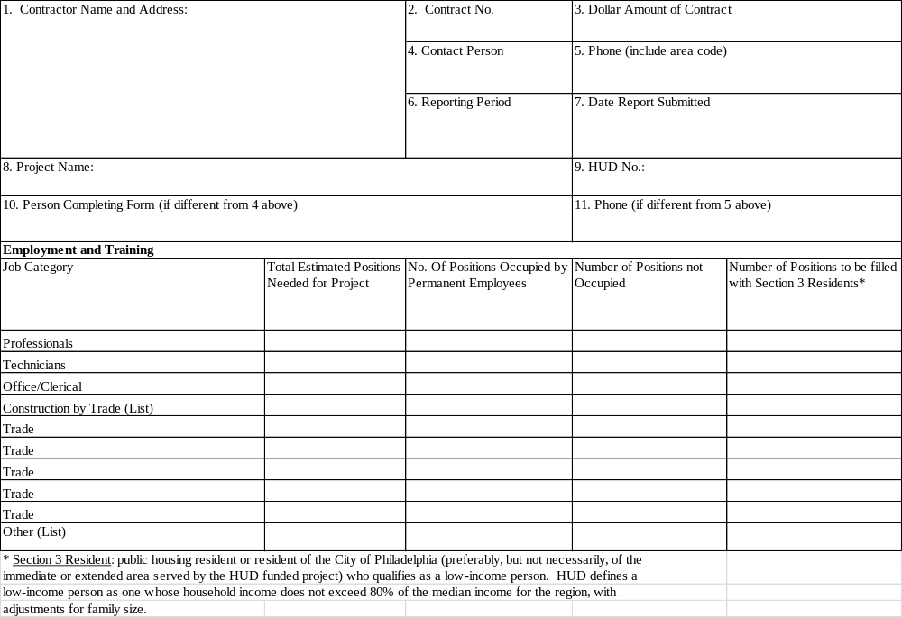

Section 3 – Form C
City of Philadelphia
Division of Housing & Community Development

CERTIFICATION FOR BUSINESS CONCERNS SEEKING SECTION 3
PREFERENCE IN CONTRACTING AND DEMONSTRATION OF CABILITY
To be used for PRA & PHDC Projects

Name of Business: _________________________________________________________________________

Address of Business: _______________________________________________________________________

Type of Business: Corporation Partnership

Sole Proprietorship Joint Venture

Attached is the following documentation as evidence of status:

For Business claiming status as a Section 3 resident-owned enterprise:
Copy of resident lease Copy of receipt of public assistance

Copy of evidence in participation Other evidence

in a public assistance program

For business entity as applicable:
Copy of Articles of Incorporation Certificate of Good Standing

Assumed Business Name Certificate Partnership Agreement

List of owners/stockholders and Corporation Annual Report

% ownership of each Latest Board minutes appointing officers

Organization chart with names and titles Additional Documents

For business claiming Section 3 status by subcontracting 25 percent of the dollar awarded to
qualified Section 3 business:
List of subcontracted Section 3 business(es) and subcontract amount

For business claiming Section 3 status, claiming at least 30 percent of their workforce are currently
Section 3 residents or were Section 3 eligible residents within 3 years of date of first employment
with the business:
List of all current full-time employees List of employees claiming Section 3 status

PHA/IHA Residential lease less than 3 Other evidence of Section 3 status less than years from date of employment years from date of employment

Evidence of availability to perform successfully under the terms and conditions of the proposed contract:
Current financial statement

Statement of ability to comply with public policy

List of owned equipment

List of all contracts for the past two years

I understand that false statements made herein are subject to the penalties of 18 Pa C.S.A 4904 relating to unsworn falsification to authorities.

Authorized Name & Signature: ________________________________

Attested by: _______________________________________________

Date: __________________

Section 3 – Form D
Section 3 of the Housing & Urban Development Act of 1968
RESIDENT VERIFICATION FORM
To be used for Philadelphia Redevelopment Authority and
Philadelphia Housing Development Corporation projects

Section 3 is a provision of the Housing and Urban Development Act of 1968 (12 U.S.C 1701u) (section 3) to ensure that employment and other economic opportunities generated by certain HUD finance assistance shall, to the greatest extent feasible, and consistent with existing Federal, State and local laws and regulations, be directed to low- and very low- income persons, particularly those who are recipients of government assistance for housing, and to business concerns which provide economic opportunities to low- and very low-income persons.

Eligibility for Preference
A Section 3 resident seeking preference in training and employment provided by this part shall certify, or submit evidence to the recipient contractor or subcontractor, if requested, that the person is a Section 3 resident, as defined in Section 135.5

Those seeking to certify as a Section 3 resident, after reading the eligibility guidelines* on the following page, should fill in the form below, sign, date and submit this page along with the appropriate documentation** to the project contractor.
Certification for Resident Seeking Section 3 Preference in Training and Employment

I, ____________________________________________, am a legal resident of the

_______________________________________________ and meet the income eligibility guidelines for a low-

or very low- income person as published on the reverse.

My permanent address is: ___________________________________________________________

____________________________________________________________

I have attached the following documentation as evidence of my status:

___ Copy of lease ___ Copy of receipt of public assistance

___ Copy of Evidence of participation ___ Other evidence
In a public assistance program

I understand that false statements made herein are subject to penalties of 18 Pa C.S.A. 4904 relating to unsworn falsifications to authorities.

Signature: _______________________________________ Date: _________________________

Printed Name: __________________________________________________________________________

SECTION 3 INCOME LIMITS

All residents of public housing developments of the Philadelphia Housing Authority qualify as Section 3 residents. Additionally, individuals residing in the City of Philadelphia who meet the income limits set forth below can also qualify for Section 3 status.

A picture identification card and proof of current residency is required.

2026 income Guidelines
Number in Household | Very Low Income | Low Income
1 Individual | $42,950 | $68,750
2 Individuals | $49,100 | $78,550
3 Individuals | $55,250 | $88,350
4 Individuals | $61,350 | $98,150
5 Individuals | $66,300 | $106,050
6 Individuals | $71,200 | $113,900
7 Individuals | $76,100 | $121,750
8 Individuals | $81,000 | $129,600

*Please be advised that this is the 2024 guideline. Eligibility Guidelines are updated every year and can be found on HUD’s website at https://www.huduser.gov/portal/datasets/il.html

** Documentation
Acceptable documentation includes, but is not limited to the following:

      - Proof of residency in a public housing development
      - Evidence of participation in a HUD Youth Build program operated in the metropolitan (or non-metropolitan county) where the Section 3 covered assistance is spent;
      - Copy of Section 8 voucher or certificate
      - Evidence of eligibility or participation in a federally assisted program for low- and very low- income persons (e.g. Jobs JTPA, Job Corps, etc.);
      - Evidence that the individual resides in the Section 3 area and is a low- or very low- income person as defined in Section 3(b)(2) of the US Housing Act of 1937 (1937 Act);
      - Other acceptable documentation to the Recipient

TAX STATUS CERTIFICATION REQUEST

Taxpayer Name: ____________________________ Date: _____________________

Taxpayer Trading As: ____________________________________________________

Home Address: ________________________________________________________

Business Address: ______________________________________________________

1. Are you a Registered Taxpayer? Yes [ ] No [ ]
If so, Philadelphia A/C #
Social Security Number

2. Identify all your subsidiaries and affiliates:

3. Are you or any of your subsidiaries or your affiliates Yes [ ] No [ ]
presently delinquent in any City of Philadelphia School
District Taxes, business taxes and/or others taxes?
If so, what tax(es) and amount(s) owed:

4. Are you or any of your subsidiaries or affiliates Yes [ ] No [ ]
presently delinquent in Water and Sewer Changes
and/or Philadelphia Gas Works Payments?
If so, amount(s) owed:
______________________________________________________________________

5. Have you or any of your subsidiaries or affiliates Yes [ ] No [ ]
been sued by the City of Philadelphia?
If so, list date(s) and nature of law suit(s):

6. Are you or any of your subsidiaries or affiliates Yes [ ] No [ ]
involved in any other business activity? If so, list
company name and describe activity:
______________________________________________________________________

7, Do you or any of your subsidiaries or affiliates
own real estate? Yes [ ] No [ ]
If so, list address (es) here or back of this form.

I hereby affirm that the information provided above is true and correct to the best of my
knowledge, information and belief; said affirmation being made subject to the penalties
prescribed by 18 Pa. C. S. A. Sec. 4904 relating to unsworn falsifications to authorities.

Name: ________________________________________________________________

Signature: ___________________________________ Date: _____________________

CONFLICT OF INTEREST

Applicants for assistance involving Community Development Block Grant ("CDBG") funds are required to comply with federal regulations regarding conflicts of interest. The regulations affect the following groups of people:

  - Employees, consultants and officers of the City of Philadelphia and its quasi-city agencies and departments;
  - Elected or appointed officials of the City of Philadelphia, the Commonwealth of Pennsylvania or the federal government of the United States; and
  - Employees, consultants or officers of any firm receiving CDBG program funds.

You must answer the following questions to determine if a conflict of interest exists:

- Are you now, or have you been within the preceding year in one of the categories (a, b or c) described above?

Yes __________ No __________

- Is any member of your family or your spouse’s family now or have they been within the preceding year in one of the categories (a, b or c) described above? (Family members include spouses, parents, siblings and children.)

Yes __________ No __________

- Is any business associate (see prior definition) of yours now or have they been within the preceding year in one of the categories (a, b or c) described above?

Yes __________ No __________

SIGNATURE: ______________________________________DATE: _____________________

TITLE: _____________________________ COMPANY: ____________________________

STATEMENT OF NO PENDING OR THREATENED LITIGATION

Other than as attached, there is no pending or threatened litigation, claim, consent order, settlement agreement, investigation, challenge or other proceedings being brought by applicant, and/or any business associate of applicant against the City of Philadelphia or any of its departments, its Division of Housing and Community Development ("DHCD"), the Philadelphia Housing Development Corporation ("PHDC"), the Philadelphia Land Bank ("PLB"), the Philadelphia Redevelopment Authority ("PRA") or the Philadelphia Industrial Development Corporation ("PIDC").

A business associate includes, but may not be limited to: officers, directors, partners, employees, lenders, lessors, and consultants. Depending on the circumstances, business associates may also include shareholders, landlords, sellers of real estate, agents, representatives, subsidiaries, affiliates, or joint ventures. Applicants are encouraged to use a broad definition of "business associate" when completing this and other questions where that term is used.

On an attached sheet, list the following information regarding any pending or threatened litigation, claim, consent order, settlement agreement, investigation, challenge or other proceeding: name(s) of parties, type of proceeding, claim, etc.; status of proceeding, claim, etc.

NAME (print): __________________________________________________________

TITLE: ________________________________________________________________

COMPANY: ____________________________________________________________

SIGNATURE: ___________________________________________________________

DATE: __________________________________________________________________
ANTI-LOBBYING CERTIFICATION

I, _____________________, on behalf of ____________________________________ ("Contractor"), hereby certify that I have been duly authorized to execute this Certification on behalf of Contractor and that no Federally-appropriated funds have been paid or will be paid by or on behalf of Contractor to any person for influencing or attempting to influence an officer or employee of any agency, a Member of Congress, an officer or employee of Congress, or an employee of a Member of Congress in connection with the awarding of any Federal contract, the making of any Federal grant, the making of any Federal loan, the entering into of any cooperative agreement, and the extension, continuation, renewal, amendment or modification of any Federal contract, grant, loan or cooperative agreement.

Contractor will provide immediate written notification to PHDC if Contractor learns that the above certification was erroneous when submitted or has become erroneous because of changed circumstances.

On behalf of Contractor, I also certify that Contractor has required and will continue to require during the term of this Contract, this same certification from its contractors.

I verify and affirm that the statements made in this certification are true and correct in all material ways. I understand that any false statements contained herein are made subject to the penalties of 18 Pa.C.S. § 4904 relating to unsworn falsification to authorities.

Signature: __________________________
Title: ______________________________
Date: ____________________

Witness Name: ________________________________
Witness Signature: ______________________________
Date: _____________________

PHILADELPHIA CODE CHAPTER 17-1300 CERTIFICATION
MINIMUM WAGE / BENEFIT ORDINANCE

Section A: Gross Receipts

Contractor, __________________________________________________ certifies that Contractor’s gross receipts are:

___ $1,000,000 per year or less
(Skip to Signature line)

___ in excess of $1,000,000 per year
(Complete Section B)

Section B: Minimum Wage

Contractor certifies that all employees working on this PHDC program will be paid a minimum of $15.00 per hour, excluding benefits. Employees being paid less than $15.00 per hour should be listed below:

Employee Classification Hourly Rate

________________________ ___________

________________________ ___________

________________________ ___________

_____________________________________________ _________________________
Signature Date

Printed Name & Title

Philadelphia Housing Development Corp. (PHDC), Philadelphia Redevelopment Authority (PRA), Philadelphia Land Bank (PLB)
Disclosure Forms

Directions:
- Please read the following information regarding the completion of these disclosure forms. Please review the definitions prior to completing any form.
- Date and initial the top of each form after you have completed it and sign the form on the last page.
- NOTE: There are two different types of campaign contribution disclosure forms: one for those who are applying as individuals and one for those applying as businesses. Only fill out one type of form. (If you have used a consultant with respect to applying for this financial assistance you will have to fill out a campaign contribution disclosure form for them as well.)

Getting Started
There are five sets of disclosure forms enclosed in this packet. You must provide information for each disclosure form. The information you must disclose includes:
- Any contributions (defined as a provision of money, in-kind assistance, discounts, forbearance or any other valuable thing) made during the two years prior to the application submission date or prior to your receipt of financial assistance in the absence of an application.
- The name of any consultant(s) you used to help in obtaining this financial assistance and any campaign contributions they have made;
- Any subcontractors you are planning to use if awarded this financial assistance:
- Whether a City or Housing Agency (PHDC, PRA, PLB) employee or official asked you to give money, services, or any other thing of value to any individual or entity; and
- Whether a City of Housing Agency (PHDC, PRA, PLB) employee or official gave you any advice on ow to satisfy any minority, women, disabled or disadvantaged business participation goals.

More Information on Disclosing Campaign Contributions
Applicants for financial assistance must disclose any contributions they made to:
- Any candidate for nomination or election in any public office in the Commonwealth of Pennsylvania
- An incumbent in any public office in the Commonwealth of Pennsylvania
- A political committee or state party in the Commonwealth of Pennsylvania
- A group, committee, or association organized in support of any candidate, office holder, political committee, or state party in the Commonwealth of Pennsylvania

The types of contributions that must be disclosed include:
- An advance or deposit of money, gift, or any other valuable thing given to a candidate or political committee for the purpose of influencing any election in the Commonwealth of Pennsylvania
- The purchase of tickets for events such as dinners, luncheons, rallies, and all other fun-raising events
- Granting of rebates or discounts not available to the general public or rebates by television and radio stations and newspapers not extended on an equal basis to all candidates
- Any payments made on behalf of candidates not made by either the candidate or their committee

Attribution Rules. In addition to disclosing contributions made directly by the applicant, the applicant will be asked to supply information on other types of contributions. The campaign contribution disclosure forms will include questions that specifically ask for information on these other types of contributions. These contributions will b attributed to the individual or business and will be used to determine the applicant’s eligibility to receive financial assistance.

Businesses (i.e., corporation, limited liability company, partnership association, joint venture or any other legal entity) have to disclose contributions made by the following:
- Applicant business
- Parent, subsidiary, or otherwise affiliated entity of the applicant business ("affiliate")
- An individual or business that is then reimbursed by the applicant business or affiliate
- Officers, directors, controlling shareholders, or partners of the for-profit applicant business or for-profit affiliate
- Political action committee controlled by the applicant business or affiliate
- Political action committee controlled by officer, director, controlling shareholder, or partner of the for-profit applicant business or for-profit affiliate

Individuals have to disclose contributions made by the following:
- Applicant individual
- Member of individual’s immediate family (i.e., spouse, life partner, or dependent child living at home), when contributions are in excess of $3,000.

In addition to direct contributions to candidates, incumbents, or political committees in the Commonwealth of Pennsylvania, applicates are also required to disclose:
- Contributions not directly given to a candidate, incumbent, or political committee but made with the intent tat the contribution will benefit the candidate, incumbent, or political committee;
- Solicitation of contributions on behalf of a candidate, incumbent, or political committee, including the hosting of or solicitation at fundraising events (required to disclose details regarding the date of event and amount raised); and
- Contributions not made directly by the individual/business to a candidate, incumbent, or political committee but furnished by the individual/business (as an "intermediary").

Eligibility Restrictions
Effective as of January 1, 2016, if an individual makes contributions totaling over $3,000 in on calendar year to a candidate for City elective office or to an incumbent, the individual is not eligible to apply for, or enter into, any Non-Competitively Bid Contract in excess of $10,000, nor shall said individual be eligible to be a sub0-contractor (at any tier) of any such contract during that candidate’s or incumbent’s term of office. The monetary limits in effect for individuals prior to January 1, 2016 remain in effect for purposes of determining an individual’s eligibility during the two year disclosure period prior to the date an individual’s application in response to a contract opportunity is due or for determining an individual’s continuing compliance during the term of any such contract that is awarded to the individual. For the period February 1, 2006 through December 31, 2007, the contribution amount is $2,500; for the period January 1, 2008 through December 31, 2011, the contribution limit amount is $2,600; for the period January 1, 2012 through December 31, 2015, the contribution limit is $2,900.

Effective as of January 1, 2016, if a business makes contributions totaling over $11,900 in one calendar year to a candidate for City elective office or to an incumbent, the business is not eligible to apply for, or enter into, any Non-Competitively Bid Contract in excess of $25,000, nor shall said individual be eligible to be a sub-contractor (at any tier) of any such contract during that candidate’s or incumbent’s term of office. The monetary limits in effect for businesses prior to January 1, 2015 remain in effect for purposes of determining a business’ eligibility during the two-year disclosure period prior to the date a business’ application in response to a contract opportunity is due or for determining a business’ continuing compliance during the term of any such contract that is awarded to the business. For the period February 1, 2006 through December 31 2007, the contribution limit is $10,000; for the period January 1, 2008 through December 31, 2011, the contribution limit amount is $10,600; for the period January 1, 2012 through December 31, 2016, the contribution limit amount is $11,500.
Note on Eligibility: If a candidate for any City elective office contributes $250,000 or more from his or her personal resources to his or her campaign, then the eligibility thresholds for individuals and businesses shall double with respect to contributions to all candidates for that same elective office (i.e., $6,000 for individuals and $23,800 for businesses).

Definitions

Affiliate | A parent, subsidiary, or otherwise affiliated entity of a business
Applicant | An individual or business who has filed an application to be awarded a non-competitively bid contract or financial assistance
Business | A corporation, limited liability company, partnership, association joint venture or any other legal entity (including non-profit organizations) other than an Individual
Candidate | Any individual who seeks nomination or election to public office, other than a judge of elections or inspector of elections whether or not such individual is nominated or elected. An individual shall be deemed to be seeking nomination or election to such office is he or she has (1) received a contribution or made an expenditure or has given his consent for any other person or committee to receive a contribution or make an expenditure, for the purpose of influencing his or her nomination or election to such office, whether or not the individual has made known the specific office for which he or she will seek nomination for election at the time the contribution is received or the expenditure is made; or (2) taken the necessary action under the laws of the Commonwealth of Pennsylvania to qualify himself or herself for nomination or election to such office.
Consultant | A person used by an applicant to assist in obtaining financial assistance through direct or indirect communication by such individual or business with any City Housing Agency (PHDC, PRA, PLB) or the organizations providing financial assistance or any City officer or employee or officer or employee of the organization providing financial assistance, if the communication is undertaken by such individual or business in exchange for, or with the understanding of receiving payment from the applicant; provided however, that "Consultant" shall not include a full-time employee of the applicant.
Contributions | The provision of money, in-kind assistance, discounts, forbearance or any other valuable thing, during the two years prior to the deadline for the filing of the application for the contract opportunity or financial assistance, to any of the following:  - A candidate for nomination or election to any public office in the Commonwealth of Pennsylvania;  - An incumbent in any public office in the Commonwealth;  - A political committee or state party in the Commonwealth; or  - A group, committee or association organized in support of any candidate, office holder, political committee or state party in the Commonwealth
Financial Assistance | Any grant, loan, tax incentive, bond financing subsidy for land purchase or otherwise, or other form of assistance that is realized by or provided to a person in the amount of fifty thousand dollars ($50,000) or more through the agencies or approval of the City, including, but no limited to, Tax Increment Financing (TIF aid, industrial development bonds, use of the power of eminent domain, Community Development Block Grant (CDBG) aid or loans, airport revenue bonds, and Enterprise Zone or similar economic development zone designations (such as Keystone Opportunity Zones, Keystone Opportunity Expansion Zones, Keystone Opportunity Improvement Zones, and Economic Development District Zones, but not including any assistance to which a person is entitled under a law enacted before the individual or business applied for or requested such assistance.
Immediate Family | A spouse or life partner residing in the individual’s household or minor dependent children.
Incumbent | An individual who holds elective office
Intermediary | A person, who, other than in the regular course of businesses a postal, delivery or messenger service, delivers a contribution from another individual or business to the recipient of such contribution.
Person | An individual, corporation, limited liability company, partnership, association, joint venture, or any other legal entity.
Political Committee | Any committee, club, association, or other group of persons which receives money or makes expenditures for purposes of influencing any election.

Solicit a Contribution | Requesting or suggesting that a person make a contribution. The sponsoring or hosting of a fundraising event is considered soliciting a contribution from the attendees of the event. Any contributions raised at such event are counted as a contribution made by the host of the event.

If Applying as an Individual:

Campaign Contribution Disclosure Form

Please read through the directions and definitions before filling out this disclosure form to make sure that each question is answered appropriately and thoroughly. Note that you must provide information for the two years prior to the application deadline.

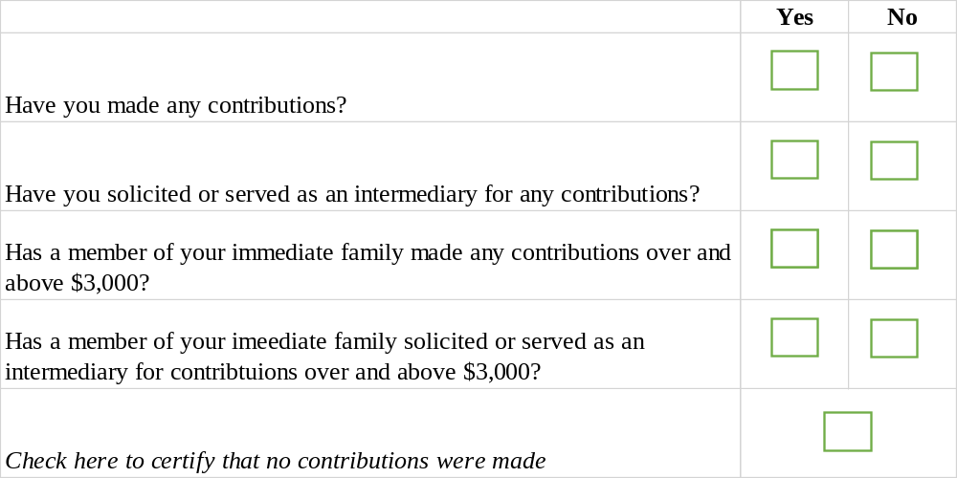

Additional information on every contribution must be disclosed.
Please us the table provided on the next page.

If Applying as an Individual:
Campaign Contribution Disclosure Form

For relationship, please indicate whether the contributor was the Individual or Family Member
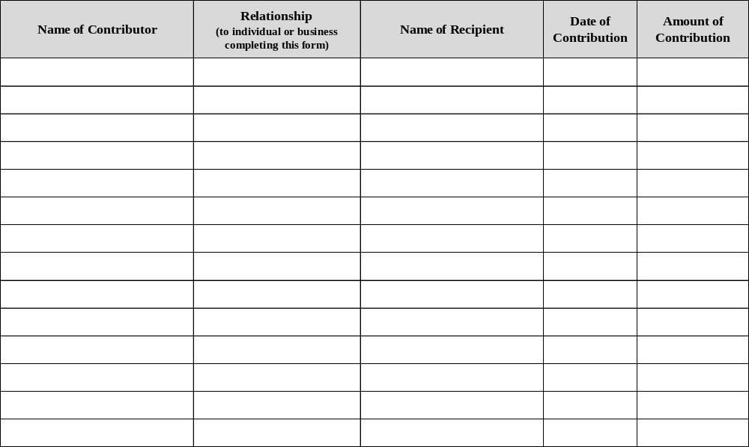

Please use additional pages as needed.
If Applying as a Business:
Campaign Contribution Disclosure Form

Please read through the directions and definitions before filling out this disclosure form to make sure that each question is answered appropriately and thoroughly. Where "no-profit" is an option, indicate whether the business is a non-profit; non-profits are not required to disclose contribution information on these questions. Note that you must provide information for the two years prior to the application deadline.
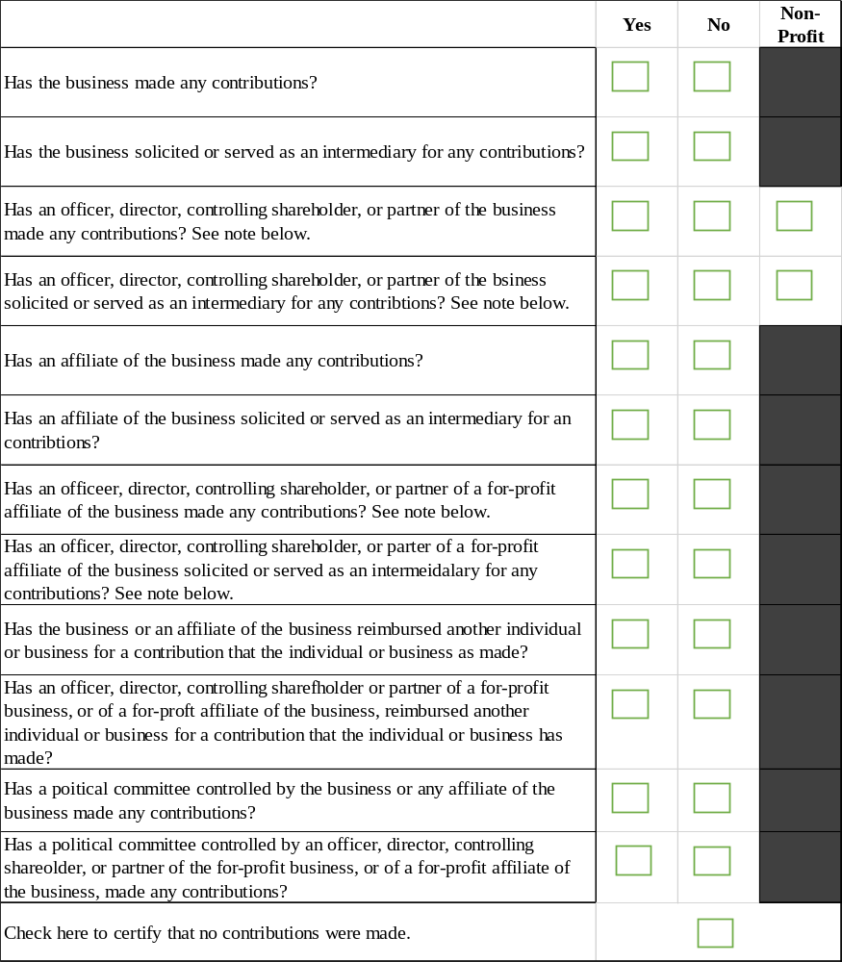

If Applying as a Business:
Campaign Contribution Disclosure Form

For relationship, indicate whether the contributor was the Business, Affiliate, Controlled Political Committee, Controlling Shareholder, Director, Officer, Parent, Partner, Reimbursed Contributor, Solicited Contributor, Subsidiary or Other.
Please use additional pages as needed.
Use of Consultant Disclosure Form

Please list all consultant(s) used in the year prior to the application deadline and the corresponding information for that consultant in the space provided below.

Please note that a Consultant, for the purposes of the required disclosure, is defined as an individual or business used by an applicant or contractors to assist in obtaining financial assistance through direct or indirect communication by such individual or business with any of the three City Housing Agencies, the organization providing financial assistance, any City officer/employee, or any officer/employee of the organization providing financial assistance, if the communication is undertaken in exchange for, or with the understanding of receiving, payment from the applicant or contractor or any other individual or business (however, "Consultant" shall not include a full-time employee of the Applicant or Contractor).

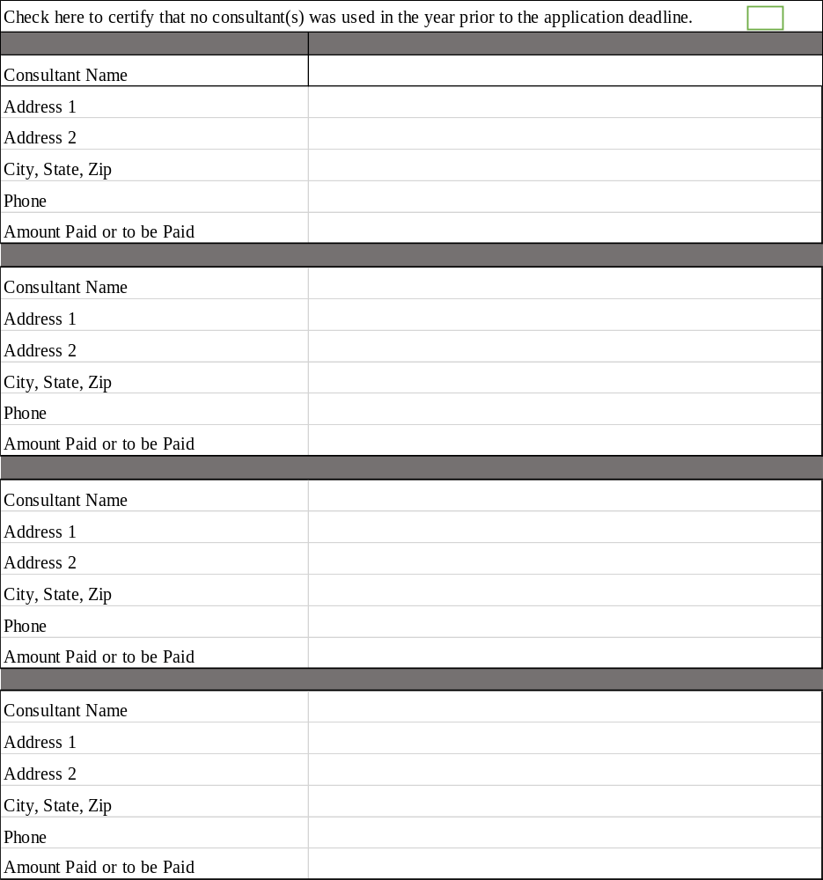
Consultant: Individual Campaign Contribution Disclosure Form

Use this form if the Consultant used is an Individual. Please read through the directions and definitions before filling out this disclosure form to make sure that each question is answered appropriately and thoroughly. Note that you must provide information for the two years prior to the application deadline.

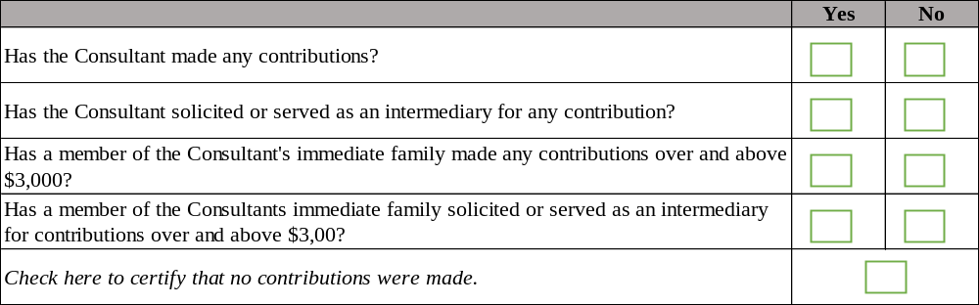

Additional information on every contribution must be disclosed.
Please us the table provided on the next page.

Consultant: Individual Campaign Contribution Disclosure Form

Use this form if the Consultant used is an Individual. For Relationship category, indicate whether the contributor was the Individual or a Family Member.

Please use additional pages as needed.
Consultant: Business Campaign Contribution Disclosure Form

Use this form if the Consultant used is a Business. Please read through the directions and definitions before filling out this disclosure form to make sure that each question is answered appropriately and thoroughly. Where "non-profit" is an option, indicate whether the business is a non-profit; non-profits are not required to disclose contribution information on these questions. Note that you must provide information for the two years prior to the application deadline.
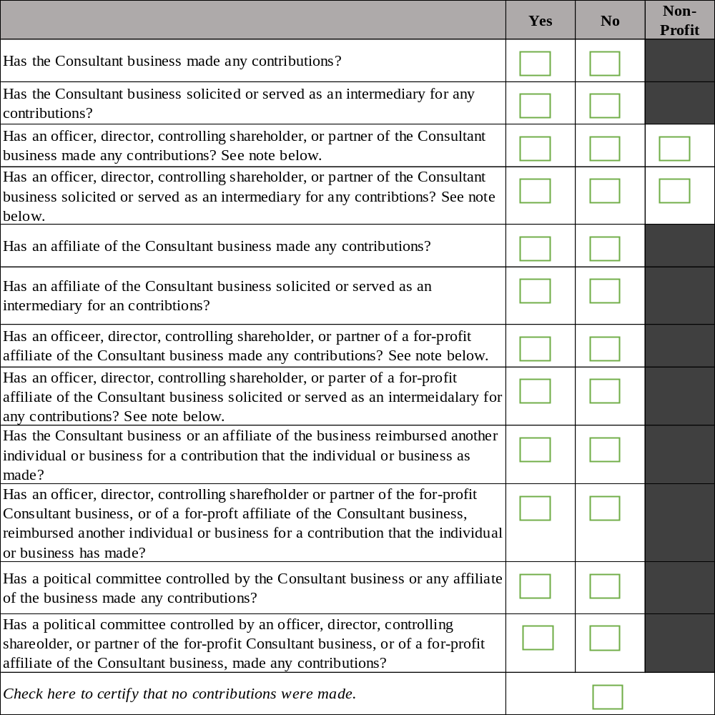
Note: Consultants must disclose all contributors to candidates or incumbents which are attributed to an immediate family member of an officer, director, controlling shareholder or partner of the for-profit Consultant or the for-profit affiliate of the Consultant. Please disclose the full amount of the contribution, although only the amount above $3,000 will be attributed to the officer, director, controlling shareholder or partner (and, by extension, the Consultant business).

Additional information on every contribution must be disclosed.
Please use the table provided on the next page.
Consultant: Business Campaign Contribution Donation Form

Use this form if the Consultant used is a Business. For relationship, indicate whether the contributor was the Consultant Business, Affiliate, Controlled Political Committee, Controlling Shareholder, Director, Officer, Parent, Partner, Reimbursed Contributor, Solicited Contributor or Other.

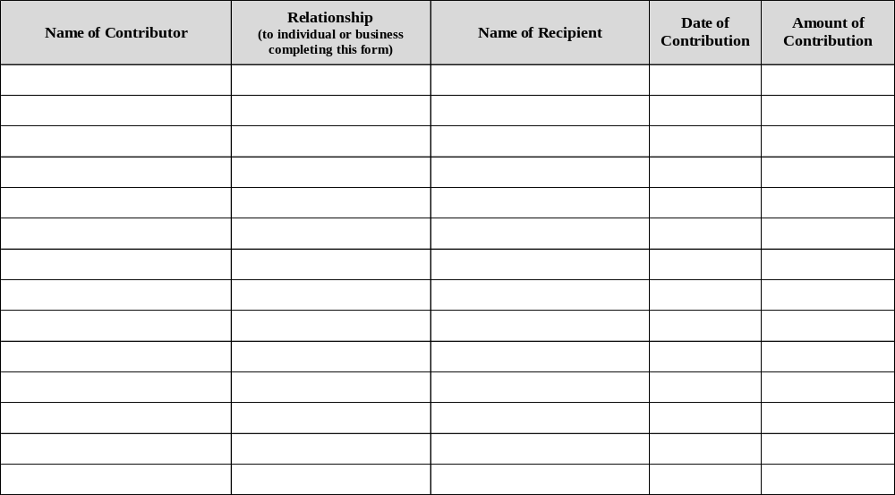
Use of Subcontractor Disclosure Form

Please list all subcontractor(s) you are planning to use if awarded this financial assistance by filling out the appropriate information in the space provided below.

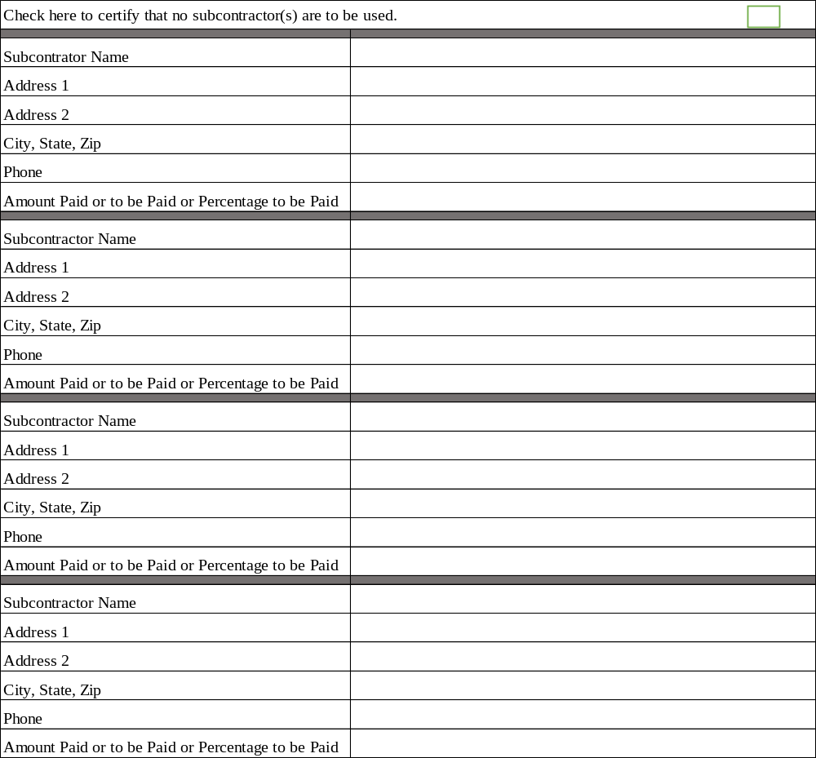

Employee Request Form

Please list any City of Housing Agency (PHDC, PRA, PLB) employees or officers or employees/officers of the organization providing financial assistance who have asked you (the Applicant), any officer, director or management employee of the Applicant, or any person representing the Applicant to give money, services, or any other thing of value (other than contributions as defined above) during the two years prior to the application deadline.

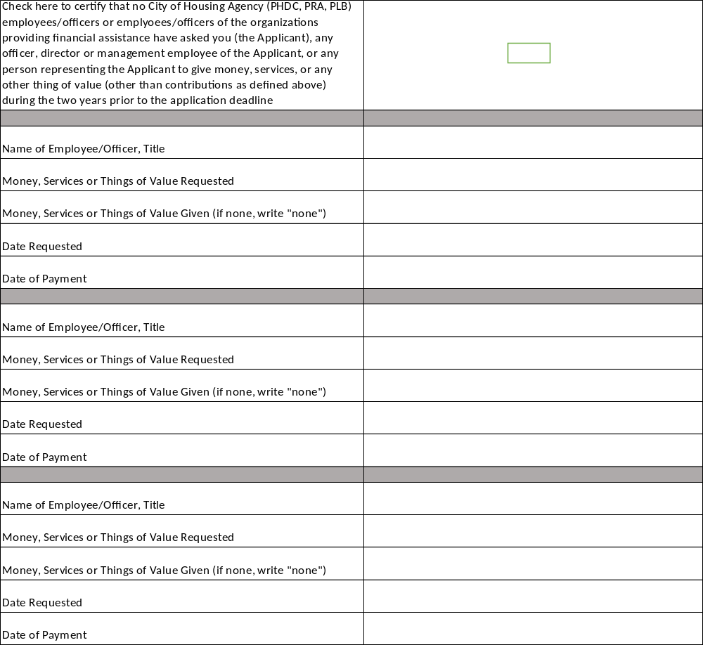

Employee Participation Advice Disclosure Form

Please list any City of Housing Agency (PHDC, PRA, PLB) employees or officers, employees/officers of the organization providing financial assistance who gave you (the Applicant) or any officer, director or management employee of the Applicant, or any person representing the Applicant.

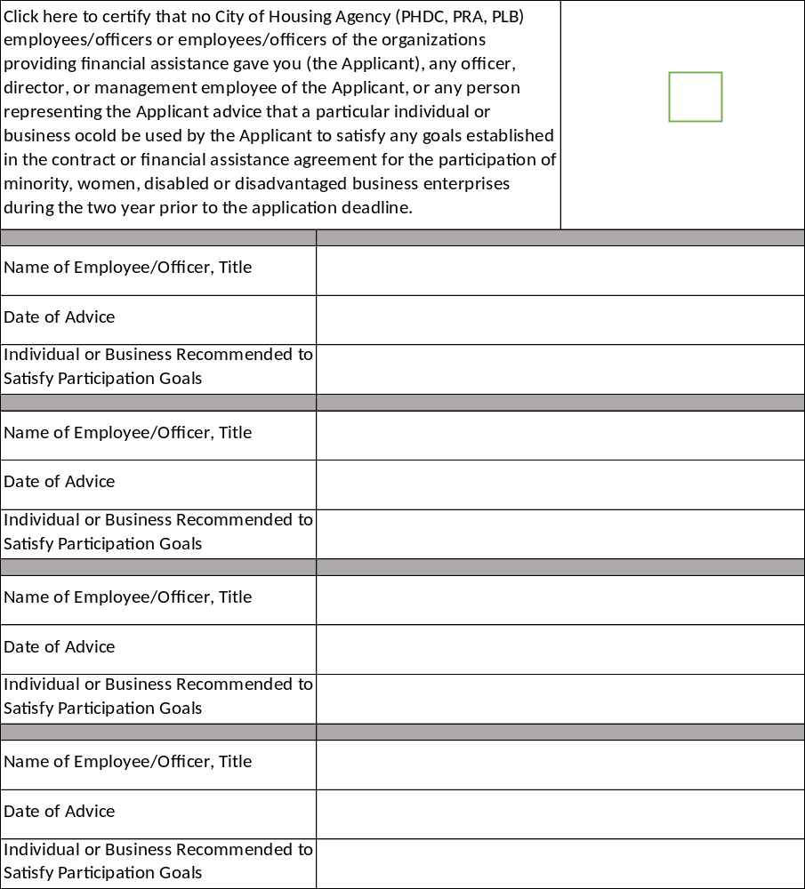
Philadelphia Housing Development Corporation
Philadelphia Redevelopment Authority
Philadelphia Land Bank

Signature

In order for the submission of these disclosure forms to be considered valid, they must be properly signed below by the respondent. Disclosure forms that are not signed will be rejected. By signing your name and title in the signature space below, you, as the respondent, signify your intent to sign these disclosure forms. The signatory hereby declares and certifies themselves to be the respondent, declares and certifies that they are properly authorized to execute these disclosure forms, and represents and covenants that all of the information and disclosures provided to the best of their knowledge are true and contain no material misstatements or omissions. Breach of such representation and covenant may render any subsequent provision of financial assistance voidable, and entitle the City (or Housing Agency (PHDC, PRA, PLB)) to all rights and remedies provided by law or equity.

If these disclosure forms are being submitted by an INDIVIDUAL, PARTNERSHIP, LIMITED LIABILITY COMPANY OR MANAGED LIMITED LIABILITY COMPANY, sign the forms here:

____________________________________ _______________________________
Signature Date

_____________________________________ _______________________________
Name Title

If these disclosure forms are being submitted by a CORPORATION, sign the forms here, with signatures by (a) President or Vice-President of the corporation AND (b) Secretary, Assistant Secretary, Treasurer or Assistant Treasurer of the corporation. If the disclosure forms are not signed by the above-mentioned, you hereby certify that you are authorized pursuant to a certified corporate resolution to sign in place of such officers.

_____________________________________ _______________________________
Signature Date

_____________________________________ _______________________________
Name President/Vice President, if other, please specify

_____________________________________ _______________________________
Signature Date

_____________________________________ _______________________________
Name Secretary/Asst. Secretary/Treasurer/Asst. Treasurer
if other, please specify.

CERTIFICATION
I

I hereby declare that I have not used any position of influence to be selected to receive assistance under a city housing program. Further, I do hereby declare that I have filed the foregoing Qualifications and do hereby certify that the statements made in the foregoing application as well as in all forms and documents that are attached are true and correct to the best of my knowledge, information and belief. I understand that false statements made herein are subject to the penalties of 18 Pa C.S.A. 4904, relating to unsworn falsification to authorities.

NAME (print): __________________________________________________________

TITLE: ________________________________________________________________

COMPANY: ____________________________________________________________

SIGNATURE: ___________________________________________________________

DATE: __________________________________________________________________

EXHIBIT A
Home Improvement Programs
CHANGE ORDER POLICY

- Change orders are submitted by the contractor, relying on his/her/its experience and expertise, to alter the original work order specifications prepared for changes necessary to address the work approved by PDHC.

- All change orders must be authorized by PHDC prior to performing work. The contractor will not receive payment for unauthorized work and, in most cases, will not receive authorization after completing work.

- The only exceptions to point # 2 are when the changes are required for the immediate health and safety of the client, or the changes are required by code. Even under these emergency conditions, the contractor must first obtain verbal or email approval from a PHDC assistant manager, manager, field supervisor or director and must submit a change order request the same day. The change order must indicate that verbal or email approval was obtained prior to change order being submitted and who gave the approval.

- The contractor shall submit change order requests in the Contractor Portal. Requests must include the correct specification number (from the current Home Improvement Program Work Item Price List) and requested quantity.

- PHDC will make every attempt to respond to all change order requests within three business days unless a fund-limit waiver is required. PHDC will strive to respond within one business day. Contractors will receive notice of responses to change orders by email.

- PHDC may authorize small and/or simple change orders without site visits. However, as part of PHDC’s responsibility to control costs and limit work to items prescribed by the program design, PHDC reserves the right to visit every site.

- PHDC Inspectors have the right to deny contractors change order requests. Contractors have the right to appeal Inspector denials. Appeals should be addressed to the Inspector’s immediate Supervisor. In such cases the Supervisor and the Inspector will consult and possibly visit the site together. The contractor may also attend. Supervisors have the authority to resolve differences between inspectors and contractors. PHDC will, again, strive to follow the guidelines of response, as explained in point # 3.

- Change order approvals are only valid when approved by a PHDC Field Supervisor. Program Manager, Manager or Director. Field Supervisor reviews are to determine the change order request is within the scope of the original work order and the case is within budget to assure sufficient fund balance in the client grant.

EXHIBIT B

SAMPLE INSURANCE CERTIFICATE
