1973 73rd Avenue
(W. Oak Lane neighborhood)
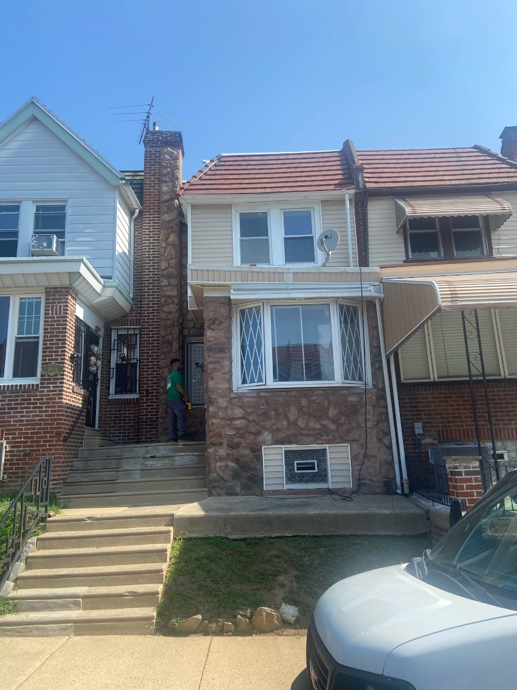
Owner: | Phila. Housing Development Corp.
Address: | 1973 73rd Avenue, Phila PA 19138
Property Type: | 3bed 2 bath Rowhome
Statement of Value: | $75,000
SF: | 1,092
Zoning: | RSA-5
Property Walk-Through Date | Thursday 12/05/24: 11:15a - 12:30p
Application Deadline | Monday 12/16/24: 4p

